**Chapter-1**

**Study of Existing system and system requirements.**

**Hardware & Software Requirement:**

**Hardware Interfaces**

* Minimum Hardware requirement
* Processor: P4 3.0 GHz
* RAM:1 GB or Higher
* Monitor
* Mouse
* Hard disk: 80 GB

**Software Interfaces**

* Minimum Software requirement
* Spring Boot
* Spring MVC
* Java (JSP and Servlet)
* Apache Tomcat Server

All these types of software automatic configure inside operating system after installation it having Java, MYSQL, Apache and operating system base configuration file, it doesn’t need to configure manually.

Introduction

As we know, the requirement for taking loans has increased tremendously in the last few years, whether it is an education loan, home loan, car loan, and etc. We want to have a system that could automate this activity at the same time it should be secured. From a loan provider’s point of view, there should be a system that should be easy to handle with no technical difficulties. For that, I have developed Loan Management System.

This application is design and develops to support Multi-User. It has a single login for every role. Admin here has the responsibility of approving and rejecting customers, field officers, loan requests, assigning Background verification, and so on. Another user is the customer whose responsibility is to request a loan, apply for a loan, and etc.

At last, we have the role of Field Officer who will accept or reject the loan request of a customer. This application will not only help the customers but also the loan officers as well as the Admin and everyone can have a common medium to be connected.

Objective

The main objective of this project is to create a secured, robust loan management system. Here, all the information on Loan is available to every user 24*7.

Here, Admin is the main user of this application and whose responsibility is to add customer, add loan officers, and assign officer for loan verifications, and so on. The other role is that of the customer who can add a loan request using this application. The loan officer on the other hand can manage all the request of loan, update verification details, and etc. effectively using Our application.

Methodologies

There are three main users of this application one is the Admin, the other is the Customer and the last one is the Loan officers/Field officers

**1) Admin**

* Admin can APPROVE/REJECT/VIEW Customer.
* Admin can APPROVE/REJECT/VIEW Loan officers.
* Admin can Assign a Loan officer for background verification.
* Admin can VIEW Loan requests.
* Admin can VIEW/UPDATE/DELETE List of background verification.
* Admin can assign Loan officer for Loan verification.
* Admin can VIEW/UPDATE/DELETE List of loan verification.
* Admin can VIEW/UPDATE the Help report.
* Admin can ADD/VIEW/UPDATE feedback questions.
* Admin can VIEW customer feedback.

**2) Customer**

* Customers can apply for a Loan.
* Customers can VIEW the loan request list.
* Customers can VIEW the Help section.
* Customers can ADD feedback.

**3) Loan Officer/Field officers**

* Both can view the Loan request assign to it.
* Both can Update Loan Verification detail.
* Both can VIEW the help report..

**Note: The login, registration and change password is common to all the user in the system.**

**Chapter-2**

**System Analysis**

**2.1 E R DIAGRAM**

**Data Flow Diagram (DFD)**

**Level 0:**

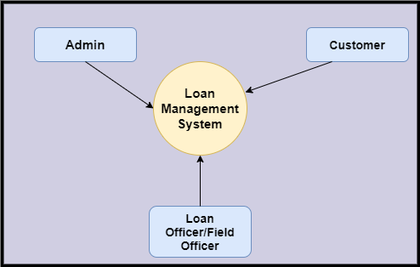

**Level 1**

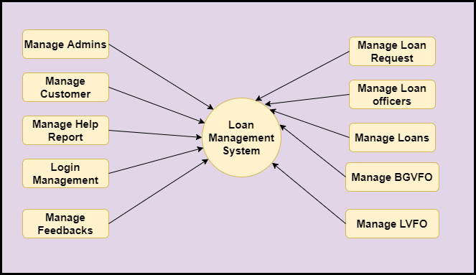

**Level 2-DFD Admin**

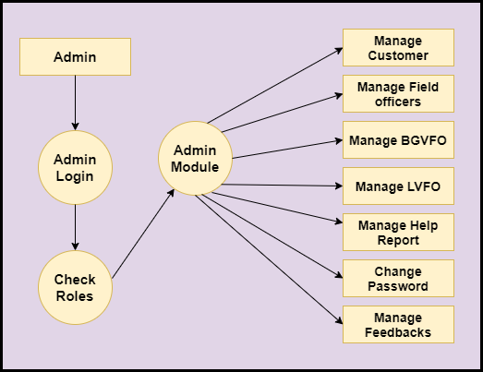

**Level 2-DFD Customer**

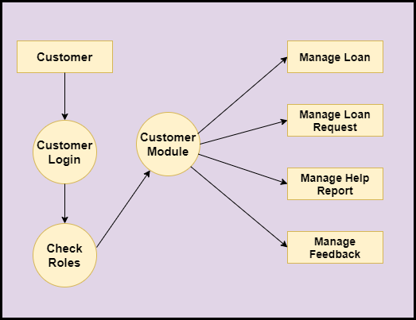

**Level 2-DFD Loan Officers**

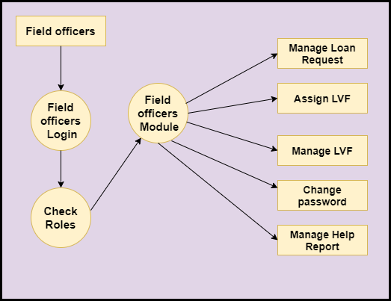

**Feasibility:**

This project will be developed on computer, so first check whether the technology is technically available or not. Now a day’s computer interaction with any job becomes common for any kind of job or work.

And because of increasing usage of Computer, Computer is also available with a variety of hardware. Vendors can fulfill any type of hardware requirement. The whole project is developed by some special tools or by using languages and databases, which are also available in a variety.

Preliminary investigation of a system examines the feasibility of a system that is useful to an organization. It is the first phase of system development.

The main objective of this phase is to identify the current deficiencies in the user’s environment and to determine which existing problem are going to be solve in proposed system and also which new function needs to be added in proposed system.

An important outcome of such preliminary investigation is to determine whether the system that will meet all needed requirements.

Thus, three tests are carried out on the system namely operation, technical and economical.

Any project is beneficial if and only satisfies the organization requirement. For any new system setup, it only meets to be communicated and work the other supporting system.

The new system meets all existing operations since it provides right information at a right time to the right user. A Leigh man can easily operate with the system.

Technical Feasibility examines whether the technology needed is available and if it is available then it feasible to carry out all project activities.

The technical needs of a system include:

* The facility to produce outputs in a given time.
* Ability to process large number of transaction at a particular speed.
* Giving response to users under certain conditions.

The technology needed for our system is mainly:

* Latest version of browsers.
* Any operating system.

These technologies are available which helps to carry out the system efficiently.

Economical feasibility of a system examines whether the finance is available for implementing the new system and whether the money spent is recoverable the satisfaction.

The cost involves is in designing and developing a good investment for the organization.

Thus, hardware requirements used for proposed system are very standard. Moreover, by making use of proposed system to carry out the work speedily will increase and also saves the valuable time of an organization.

In the proposed system the finance is highly required for the installation of the software’s which can also be recovered by implementing a better system.



**Chapter-3**

**Design**

**System Flow Chart:**

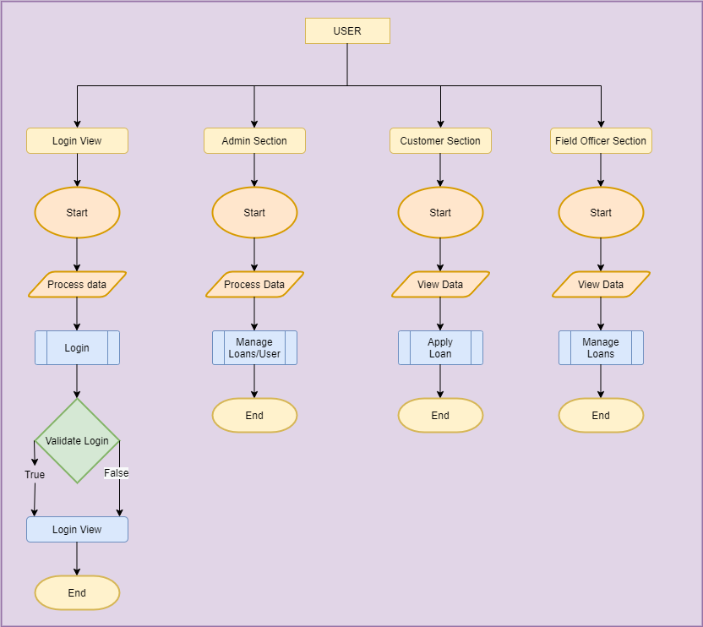

**Data dictionary**

**Data validation:**

Procedures are designed to detect errors in data at a lower level of detail. Data validations have been integrated in the system in almost every area where there is a possibility for the user to commit errors. The system will not recognize invalid data.

Whenever an invalid data is keyed in, the system immediately prompts the user and the user has to again key in the data and the system will accept the data only if the data is correct. Validations have been integrated where necessary.

The system is designed to be a user friendly one. In other words the system has been designed to communicate effectively with the user. The system has been designed with pop up menus.

**Different Type Of validation:**

* Data type validation;
* Range and constraint validation;
* Code and Cross-reference validation; and

Structured validation

**Coding**

**Implementation and Testing:**

**Black-Box Testing**:

Black Box Testing, also known as Behavioural Testing, is a software testing method in which the internal structure/ design/ implementation of the item being tested is not known to the tester. These tests can be functional or non-functional, though usually functional.

This can be following way:

* Input interfacing
* Processing
* Output interfacing



This method is named so because the software program, in the eyes of the tester, is like a black box; inside which one cannot see. This method attempts to find errors in the following categories:

* Incorrect or missing functions
* Interface errors
* Errors in data structures or external database access
* Behaviour or performance errors
* Initialization and termination errors.

**White-Box Testing:**

White Box Testing ,also known as Clear Box Testing, Open Box Testing, Glass Box Testing, Transparent Box Testing, Code-Based Testing or Structural Testing is a software testing method in which the internal structure/ design/ implementation of the item being tested is known to the tester.

The tester chooses inputs to exercise paths through the code and determines the appropriate outputs. Programming know-how and the implementation knowledge is essential.

White box testing is testing beyond the user interface and into the nitty-gritty of a system.

This method is named so because the software program, in the eyes of the tester, is like a white/ transparent box; inside which one clearly sees.

**Limitations and Future Application of the Project**

**Futures Enhancement:**

* In future we can expand this project on the web.
* In future, we can send messages to customers on phone about their schedule.

**Limitation :**

In this, we don’t block the customers from registering.

**Screen Snapshot**

**Conclusion**

The Loan Management System will help to automate the process of Loan Management where Admin can easily view registered customer, loan officers. This application helps customer to apply for loan. The Loan provider or the field officer can update the loan request after background verification.

This project can be used by the Loan provider who wants to have a common gateway and to have a multiuser application to connect with its customer and to manage the loans.

This application is designed in such a way that any future modification can be done most easily.